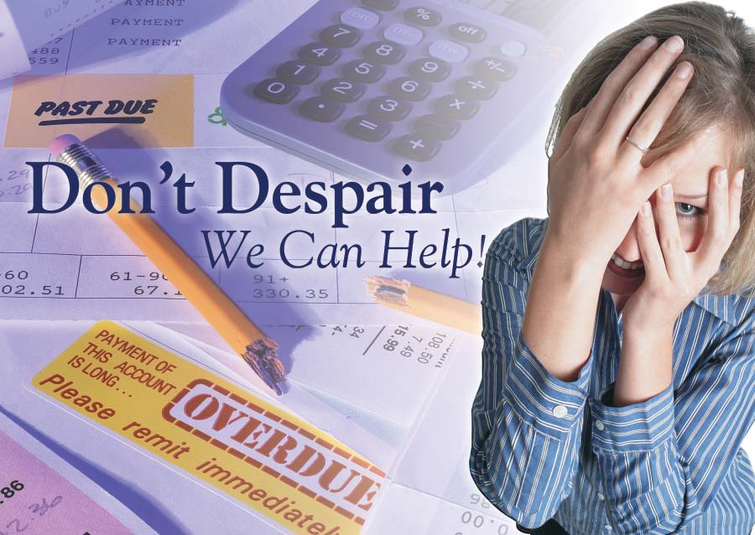

You are probably wondering,
WHO CAN HELP?

WE CAN!!! You only have a few days to respond to the courts, we
can Help...

It’s Not Too Late!!
We Can Still Pull You
Out of Foreclosure!!

SELL OR KEEP

Call Today
719-646-0004

